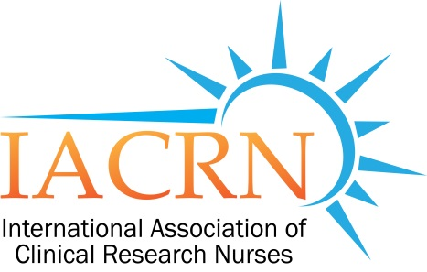
Ohio Valley Pilot Chapter of the International Association of Clinical Research Nurses

AG

MEETING MINUTES FROM MAY 20, 2015

Attendees: Lori Brunner (CCHMC), Kristal Hatter (CCHMC), Becca Harper (CCHMC), Dawn Abshire (OHC), Diane Allgeyer (CCHMC), Reem Beddawi (UC), Karla Bernard (UC), Christina Clarke (UC), Christy Cron (CCHMC), Michelle Dickey (CCHMC), Angie Duggins (CCHMC), Tara Foltz (CCHMC), Trudy Gaillard (UC), Brittany Hagen (OHC), Margery Huron (CCHMC), Marie Leist-Smith (Mercy), Carol Lindeman (Trihealth), Jenny Lohrer (CCHMC), Serena Phillips (CCHMC), Ann Pillow (CCHMC), Melissa Reed (CCHMC), Colleen Rogge (VA). Linda Roth (CCHMC), Michelle Roth (CCHMC), Kyla Scott (OHC), Kelly Thueneman (CCHMC), Tammy Weis (CCHMC)
- IACRN updates
  - Registration is open for the annual IACRN conference October 14-16th, 2015 in Baltimore, Maryland
  - New IACRN pilot chapters
    - Northeastern Oklahoma
    - Alabama, New York, Washington D.C. and Wisconsin are in the application process
- Webpage (https://cctst.uc.edu/iacrn)
  - Currently working with the IT staff of the CCTST to update the page to be more user-friendly
- Needs Assessment Results (Full results to be posted on our webpage)
  - 42 responses
  - Top 2 topics of interest for future meetings
    - Ethical dilemmas
    - Quality and safety
  - Top 2 chapter activities of interest
    - Advancing the specialty practice of research nursing
    - Collaboration between organizations to determine best practices
- Presentation by Tara Foltz and Michelle Dickey of the Gamble Institute at CCHMC
  - “Participants Just Don’t Understand…..or Do They?”
    - Simplifying the Informed Consent process
    - Link to recording of presentation will be posted on our webpage
      - https://cctst.uc.edu/iacrn
  - Continuing Education Hour
    - Issued through the parent IACRN organization
      - Contact Lori Brunner (lori.brunner@cchmc.org) if you did not receive an email from Helaine Labovitz regarding the evaluation of the presentation.
- Panel Discussion
  - Panelists
    - Trudy Gaillard (UC)
    - Marie Leist-Smith (Mercy)
    - Brittany Hagen (OHC)
    - Colleen Rogge (VA)
    - Christy Cron (CCHMC)
  - Discussion topics
    - Engaging inpatient clinical nurses in research process and data collection
      - Lead champion on unit for days/nights
      - Part of annual evaluation criteria
    - What does a research nurse do????
      - Facilitate community understanding
        - Public Service Announcement
      - Expose nursing students to research nursing while in college
        - Participate in conferences/forums at nursing schools regarding careers in nursing
PLANNING HELP NEEDED FOR OUR NEXT MEETING – SEPTEMBER 16TH
CONTACT LORI BRUNNER (lori.brunner@cchmc.org) IF INTERESTED IN HELPING
All research nurses are welcome to join us! Please invite them to our next meeting!
THANK YOU!!

