PARTNERSHIP DEVELOPMENT
GRANTS
Promoting Academic to Community Collaboration and Positive Health Outcomes

Final Proposals due January 15, 2018 by midnight

Key Dates:
Pre-Application Information Session*
October 19, 3:30 pm, United Way; 5/3 Convening Center
Letter of Intent*
November 15, 2017
Final Proposal Due
January 15, 2018
Grantees Notified
End of February 2018
Grant Project & Budget Period
March 31, 2018 - March 31, 2019

*strongly encouraged, not required

Objective:
The purpose of the Partnership Development Grant is to facilitate collaborations between academic researchers and community organizations so they can work together on health research that benefits the community. Funding can be used to develop new partnerships or to strengthen existing partnerships. These grants will allow partnerships to conduct preliminary research activities focused on health outcomes and impact that will prepare teams to apply for research grants. Examples of possible research activities include:
- Conducting a needs assessment to better understand a health problem
- Completing an environmental scan to better understand the local context of a health issue
- Facilitating activities that assess community readiness to address a health problem
- Collecting pilot data needed to demonstrate potential impact

Examples of activities that are not a good fit for this grant are facilitating meetings, providing health services, or hosting events.

Grant Funding:
Community-academic partnerships have the opportunity to receive up to
$5,000 in funding for a one-year funding period. We expect funding will be used to support preliminary research activities. For example, funding might be used to provide incentives to participants, to pay for costs associated with evaluation, or to purchase supplies needed to engage the community in research activities.
Note: all CCTST funding is for direct costs only; no facilities and administration costs are included. Funding may not be used for operating support or salaries for existing programs. Funds may also not be used for duplicative programs or purposes. Funding cannot be used for journal fees.

Who Should Apply?
The Partnership Development Grants must include at least one community partner and at least one academic partner. Community programs, agencies, physician practices and other not-for-profit organizations may apply as community partners or community principal investigators. Faculty or affiliates of CCTST partnering institutions may be considered academic partners or academic principal investigators. Applicants can be working together for the first time or part of an existing collaboration that is looking to take the next step in their work together.
All applicants are required to become a member of the CCTST at http://cctst.uc.edu/about/membership. Membership is free and entitles applicants to resources to support their programs.

Proposal Requirements and Criteria for Review:
A committee of academic and community members will review all proposals and evaluate the potential for building or strengthening a sustainable community-academic partnership, how the partnership will address community health priorities, expected outcomes, how the project will impact community health, and plans for future collaborations and the sustainability of the partnership.
We highly encourage partnerships focused on high need neighborhoods, including Avondale, Price Hill, and Covington. We also encourage partnerships focusing on asthma, mental/behavioral health, substance abuse, obesity, adult neuroscience, primary care/prevention, underserved populations, and infant mortality. However, all neighborhoods and content areas are welcomed. If your proposal is not approved for funding, it may be considered for other relevant CCTST programs.

Letter of Intent
Letters of intent are optional, but strongly encouraged. LOIs should be no more than one page and must include: (1) name, title, and contact information of coordinating partner, (2) description of both partners (academic and community partners applying for the grant), including mission, experience and or prior evidence of impact of previous work/collaboration, and (3) reason for interest in this opportunity. LOIs should be submitted to ctsa@cchmc.org by November 15, 2017 at midnight.

Application Instructions and Format
Your application must include a completed face page (1 page or less), the following sections, plus two required appendices described below. The application itself (not including appendices) should not exceed 4 pages in 12 point type.

Title of Partnership Project: Brief statement of purpose:
Why are you starting this partnership project? What is the community health concern or research question you hope to be able to address through this partnership?

Project plan:
  - Description of how this project improves the ability of the partner organizations to engage in research in the community
  - Main components of the project
  - Timeline indicating the sequence of steps in project implementation (grant activities must be completed within 12 months; the 12 month period begins upon receipt of funds.)
  - Budget with brief justification of how you arrived at the budget numbers.

Description of outcomes and impact:
- Describe the expected outcomes
- Describe how the impact of the project will be evaluated
- Briefly describe how you will measure success

Plan for future collaborations and sustainability:
- Briefly describe how the proposed project will lead to future collaborations between the academic and community partner(s)
- Describe the partnership’s options to sustain the relationship after the grant period

Appendices: Two appendices are required:
- Appendix A: Community Partners:
1-2 page description of the applicant organization’s mission, history and current work in the subject area of this proposal should be appended. If there are other collaborating agencies, they should submit letters of support that acknowledge their role in the partnership.
- Appendix B: Academic Partners:
1-2 page bio sketch of the lead academic partner must be appended. If there are additional collaborating academic partners, then please include a one to two paragraph description of the experience and interest of each relative to this proposal.
- Additional appendices of up to 3 pages should be included only if the appended material helps explain key elements of the proposal and has been referenced in the text of the proposal.

Requesting Application Materials & Submitting Final Proposals
Application materials and an FAQ document can be viewed and downloaded from the CCTST Community Engagement website (www.cctst.uc.edu/community/grants-funding-opportunities) or requested by e-mail. Questions can be directed to Stacey Gomes at (513) 803-0917 or ctsa@cchmc.org.

Mail or e-mail completed copy of your application packet to:

Cincinnati Children’s Hospital Medical Center Attn: Stacey Gomes
3333 Burnet Ave, MLC 8700
Cincinnati, OH 45220 ctsa@cchmc.org

CCTST Partnership Development Grant Face Page

- Title of Project:
- Coordinating Partner
Name
Degree(s)
Position Title
Organization/ Agency

- Academic / Community Partner
Name
Degree(s)
Position Title
Organization / Agency

- Which health topic(s) does your project address? (Check all that apply)
Asthma/Respiratory Health Mental/Behavioral Health
Adult Neuroscience Infant & Maternal Health
Underserved Populations Obesity
Primary Care Prevention Substance Abuse
Early Literacy Other; please explain:

- Do you work in any of the neighborhoods listed below? (Check all that apply)
Avondale Walnut Hills
Covington Madisonville
Price Hill Other; please explain:

- Number of Persons to be Served (Estimate):
Youth:
Adult:
Special health conditions or other (please describe):

Brief description of proposed research activities and how they will build/strengthen partnership:

- Total funds requested (no more than $5,000): $

Line Item | Dollar Amount

- Brief description of how funds will be used (i.e. budget summary):

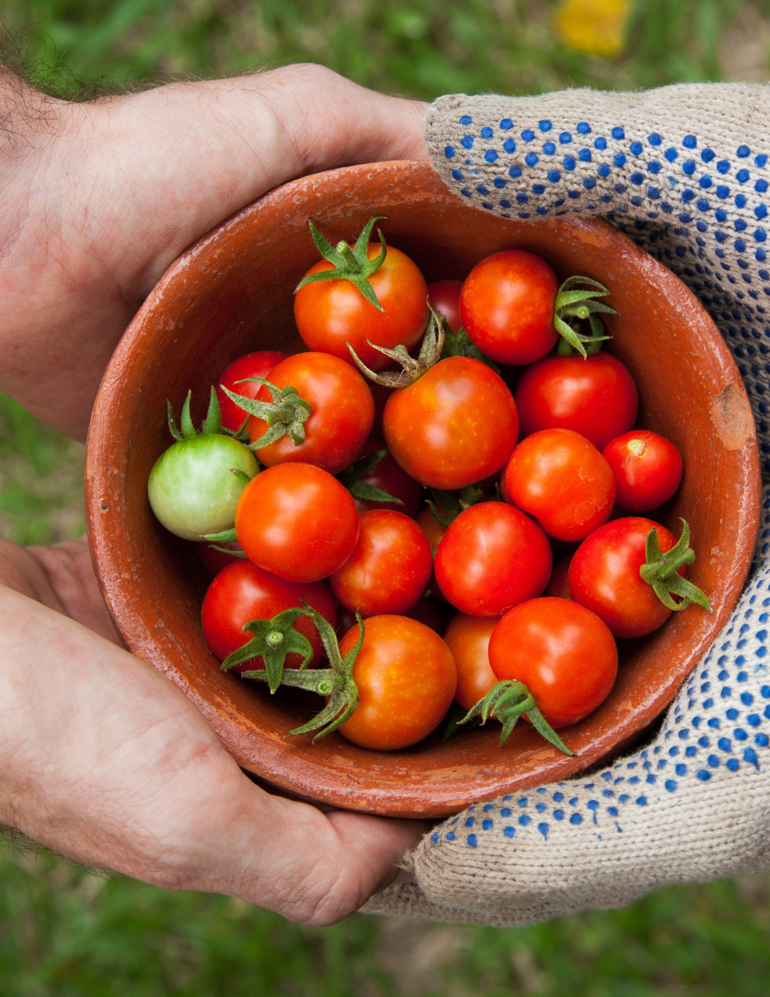

PARTNERSHIP DEVELOPEMENT
GRANTS

Thank you for your interest in the Partnership Development Grant. We look forward to receiving your application. Please feel free to call if you have any questions or concerns that are not addressed in this application package.

