COMMUNITY
HEALTH GRANTS

Promoting Academic to Community Collaboration and Positive Health Outcomes

Final Proposals due January 16, 2019 by midnight

Pre-Application Information Session**
Thursday, October 18, 3:30 pm – Interact for Health (Choice Care Room)
Letter of Intent**
November 16, 2018
Final Proposals
January 16, 2019
Grantees Notified
End of February 2019
Grant Project & Budget Period
March 31, 2019 - March 31, 2020

**strongly encouraged, not required

Objective:
This Request for Proposals is designed to elicit proposals that bring together academic researchers and community organizations/ programs to improve health and well-being in community settings. Acting in partnership, researchers and community organizations are invited to submit proposals that:

- Apply existing knowledge about health to real-world settings (also known as translational research)

- Demonstrate shared decision-making in all aspects of research activities intended to improve outcomes for our community’s children and adults

Grant Funding:
Grant applicants have the opportunity to receive up to $20,000 in funding for a one-year funding period. The funds will be awarded to partnerships between academic and community organizations or physicians that translate research into practice.

Note: all CCTST funding is for direct costs only; no facilities and administration costs are included. Funding may not be used for operating support or salaries for existing programs. Funds may also not be used for duplicative programs or purposes. Funding cannot be used for journal fees.

Who Should Apply?
Community programs, agencies, physician practices and other not-for-profit organizations may apply as community partners or community principal investigators. Faculty or affiliates of CCTST partnering institutions may be considered academic partners or academic principal investigators. Each application must have at least one academic partner and one community partner. New or developing partnerships may want to consider applying for the Partnership Development Grant: www.cctst.uc.edu/community/grants-funding-opportunities.

* All applicants are required to become a member of the CCTST at http://cctst.uc.edu/about/membership. Membership is free and entitles applicants to resources to support their programs.

Proposal Requirements and Criteria for Review:
The CCTST is committed to funding projects that exemplify two core factors: collaboration between academic and community partners and high quality translational research (i.e., research that applies existing knowledge to our local community). A committee of academic and community members will review all proposals and evaluate the strength of the partnership, funding requested and potential for translation and impact when making awards.
Applicants that propose to work collaboratively to impact the health of individuals (children and/or adults, etc.), clearly articulate the goals of their program including related outcomes and measures, and are able to evaluate and sustain these efforts beyond the grant period will be most competitive.
We highly encourage partnerships focused on high need neighborhoods, including Avondale, Price Hill, Covington, Walnut Hills, and Madisonville. We also encourage partnerships focusing on asthma, mental/behavioral health, substance abuse, obesity, adult neuroscience, primary care/prevention, underserved populations, and infant and maternal health. However, all neighborhoods and content areas are welcomed.
The proposed programs and numbers served should be described relative to the dollars requested. If your proposal is not approved for funding, it may be considered for other relevant CCTST programs.

Letter of Intent (LOI)
Letters of intent are optional, but strongly encouraged. LOIs should be no more than one page and must include: (1) name, title, and contact information of coordinating partner, (2) description of both partners (academic and community partners applying for the grant), including mission, experience and or prior evidence of impact of previous work/collaboration, and (3) reason for interest in this opportunity. LOIs should be submitted to ctsa@cchmc.org by November 16, 2018 at midnight.

Application Instructions and Format
Your application should include the following sections, two required appendices (described below), and a completed face page (one page or less). The completed application should not exceed 6 pages, including the face page, with 1 inch margins and 11 point Arial font. Include Letters of Support from all partners and resumes/CVs for lead partners with your proposal. Please limit appendices to only information that is vital for the review. Incomplete submissions may not be considered for funding.

Strengths of the individual, organization or collaborative:
- Highlight strengths of the applicant/organization applying for the grant
- Highlight the strengths of the partnering applicant(s)/organizations(s)

Description of proposed health program or translational research project, including key health challenges and questions that will be addressed through the project:
a) Describe how grant funds will be used to answer important questions about health and/or improve health in a targeted population in our community

Description of the proposed partnership, impact, and the innovation of the project:
- Describe the partnership and how the partnering organizations/agencies operate or work together to accomplish the proposed goals
- Describe the number of proposed individuals to be impacted as a result of this project
- Describe how the proposed partnership will be effective in impacting those served
- Describe how the proposed program is innovative in advancing health, health research, health quality, or translational research
- Provide any prior evidence of impact (quantitative or qualitative information/data) to support the feasibility of the proposed application
- Provide a brief (1-2 sentences) impact statement describing why your project is important. What is the primary long-term goal or greater impact beyond this project/study? How does completion of the current project/study help you achieve this long-term goal?

Research and/or evaluation plan:
- Describe the outcomes
- Describe how the impact of the project will be evaluated
- Describe what measures will be used

Community benefits and sustainability plan:
- Briefly describe how the proposed project benefits the community and improves health outcomes
- Describe the ways that the grant outcomes and/or impact might be sustained beyond the grant period (e.g., future grant mechanisms to fund the work, policy changes based on the research, changes in the community organization’s ability to fulfill their mission)
- Describe the relationship between the academic and community partners once the grant period ends

Project and budget timeline:
- Provide a budget for the project and timeline of activities
- Discuss how the grant funding will be distributed between the academic and community partners
- For applicants requesting greater than $10,000, describe how the grant will be administered with a reduced budget (i.e.: 10-25% less than proposed funding)

Required Materials Checklist:
- A face page (maximum one page/provided below)
- A project proposal, with the required elements described (maximum 6 pages)
- CVs/resumes of lead partners
- A letter of agreement signed by both partners specifically describing the roles that each partner will have in the project.
- Letters of support (optional)

Requesting Application Materials & Submitting Final Proposals
Application materials and FAQ document can be viewed and downloaded from the CCTST Community Engagement website (www.cctst.uc.edu/community/grants-funding-opportunities) or they can be requested by e-mail (ctsa@cchmc.org). Questions can be directed to Stacey Gomes at (513) 803-0917 or ctsa@cchmc.org.

Mail, e-mail, or fax completed copy of your application packet to:

Cincinnati Children’s Hospital Medical Center Attn: Stacey Gomes
3333 Burnet Ave, MLC 8700
Cincinnati, OH 45220 ctsa@cchmc.org

CCTST Community Health Grant Face Page

Title of Project:
- Coordinating Partner
Name
Degree(s)
Position Title
Organization/ Agency

Academic / Community Partner
Name
Degree(s)
Position Title
Organization / Agency

- Which health topic(s) does your project address? (Check all that apply)
Asthma/Respiratory Health Mental/Behavioral Health
Adult Neuroscience Infant & Maternal Health
Underserved Populations Obesity
Primary Care Prevention Substance Abuse
Early Literacy Other; please explain:

Number of Persons to be Served (Estimate):
Youth:
Adult:
Special health conditions or other (please describe):

Brief Description of Proposed Project/Abstract:

- Total funds requested (no more than $20,000): $

Line Item | Dollar Amount

- Brief description of how funds will be used (i.e. budget summary):

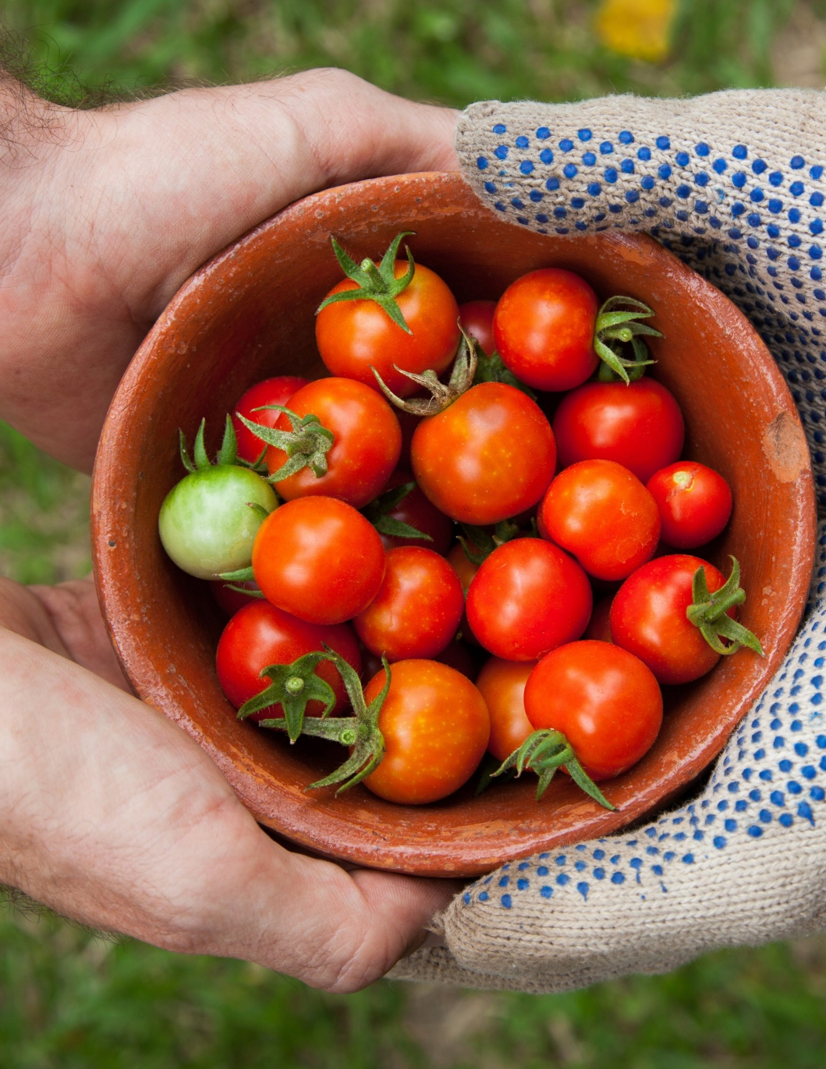

COMMUNITY
HEALTH
GRANTS

Thank you for your interest in Community Health Grants.
We look forward to receiving your application. Please feel free to call if you have any questions or concerns that are not addressed in this application package.

